Venezuela:
On the Path to Development


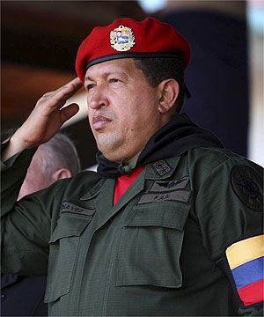

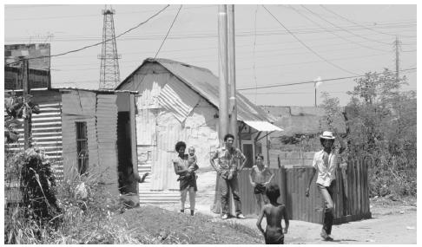

Claire Sullivan Sarah O’Neill Tamara Nisic
March 29, 2008

